**Scenario 3: A web application needs a reverse proxy setup for load balancing. How would you set up an NGINX reverse proxy to distribute traffic among multiple backend servers?**

Ans: Step 1: Install NGINX

* On Ubuntu/Debian



* On CentOS/RHEL



Step 2: Configure NGINX as a Reverse Proxy and Load Balancer

* Open the NGINX Configuration File:
* The main configuration file is usually located at /etc/nginx/nginx.conf.
* Alternatively, you can create a new configuration file in the /etc/nginx/conf.d/ directory, for example, /etc/nginx/conf.d/load_balancer.conf.
* Define the Backend Servers:
* Use the upstream directive to define a group of backend servers.

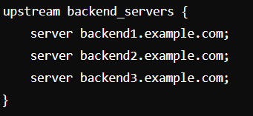

* Configure the Reverse Proxy:
* Set up a server block to listen for incoming requests and proxy them to the backend servers.

Step 3: Additional Load Balancing Configuration

* Load Balancing Methods:
* By default, NGINX uses round-robin load balancing. You can specify different load balancing algorithms such as least_conn (least connections) or ip_hash (session persistence based on client IP).

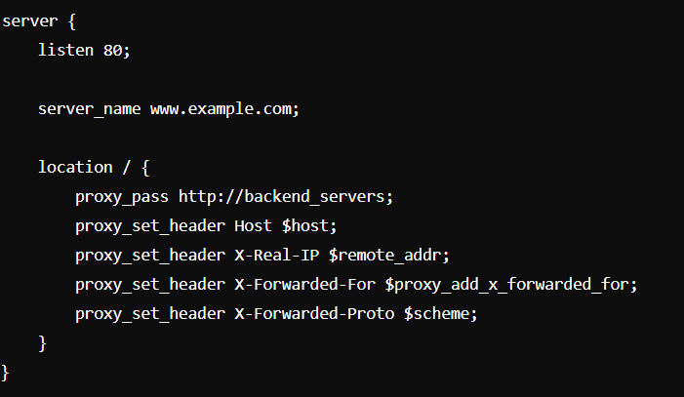

* Health Checks:
* Configure NGINX to periodically check the health of backend servers and remove unhealthy ones from the load balancing pool.
* Sticky Sessions:
* Sticky sessions ensure that a user is always directed to the same backend server.
* Nginx

Step 4: Test and Restart NGINX

Test the Configuration:

Step 5: Verify the Setup

Check the Logs:

Verify that requests are being distributed among the backend servers by checking the access logs.